**CHAPTER 7**

**CRYSTAL OSCILLATOR**

**7.1 INTRODUCTION**

A Crystal Oscillator is an [electronic oscillator](https://en.wikipedia.org/wiki/Electronic_oscillator) circuit that uses the mechanical [resonance](https://en.wikipedia.org/wiki/Resonance) of a vibrating [crystal](https://en.wikipedia.org/wiki/Crystal) of [piezoelectric material](https://en.wikipedia.org/wiki/Piezoelectricity#Materials) to create an electrical signal with a precise [frequency](https://en.wikipedia.org/wiki/Frequency). This frequency is commonly used to keep track of time, as in [quartz wristwatches](https://en.wikipedia.org/wiki/Quartz_clock), to provide a stable [clock signal](https://en.wikipedia.org/wiki/Clock_signal) for [digital](https://en.wikipedia.org/wiki/Digital_data) [integrated circuits](https://en.wikipedia.org/wiki/Integrated_circuits), and to stabilize frequencies for [radio transmitters](https://en.wikipedia.org/wiki/Radio_transmitter) and [receivers](https://en.wikipedia.org/wiki/Radio_receiver). The most common type of piezoelectric resonator used is the [quartz](https://en.wikipedia.org/wiki/Quartz) crystal, so oscillator circuits incorporating them became known as crystal oscillators, but other piezoelectric materials including polycrystalline ceramics are used in similar circuits.

Quartz crystals are manufactured for frequencies from a few tens of [kilohertz](https://en.wikipedia.org/wiki/Kilohertz) to hundreds of megahertz. More than two billion crystals are manufactured annually. Most are used for consumer devices such [wristwatches](https://en.wikipedia.org/wiki/Wristwatch" \o "Wristwatch), [clocks](https://en.wikipedia.org/wiki/Clock), [radios](https://en.wikipedia.org/wiki/Radio), [computers](https://en.wikipedia.org/wiki/Computer), and [cell phones](https://en.wikipedia.org/wiki/Cellphone). Quartz crystals are also found inside test and measurement equipment, such as counters, [signal generators](https://en.wikipedia.org/wiki/Signal_generator), and [oscilloscopes](https://en.wikipedia.org/wiki/Oscilloscope).

**7.2 OVERVIEW**

The quartz crystal oscillator circuit diagram can be represented as follows:

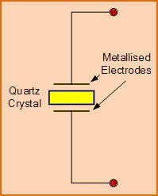

**Figure:**  Electronic symbol for a piezoelectric crystal resonator

**Crystal Oscillator Working**

The atoms, molecules, ions are packed in an order in three spatial dimensions with repeating pattern to form a solid that can be called as a crystal. The crystal can be made by almost any object that is made of elastic material by using appropriate [electrical transducers](http://www.edgefx.in/different-types-of-sensors-with-applications/). As every object consists of natural resonant frequency of vibration, steel consists of high speed of sound and is also very elastic.

Thus, steel is frequently used instead of quartz in mechanical filters. This resonant frequency depends on different parameters such as size, elasticity, speed of sound, and shape of the crystal. In general, the shape of high frequency crystals is simple rectangular plate and the shape of low frequency crystals is tuning fork shape as shown in the figure below.

Crystal oscillator circuit works on the principle of the inverse piezoelectric effect, i.e., a mechanical deformation is produced by applying an electric field across certain materials. Thus, it utilizes the vibrating crystal’s mechanical resonance which is made of a piezoelectric material for generating an [electrical signal](http://www.edgefx.in/solar-charge-controller-circuit-using-microcontroller/) of a specific frequency.

These quartz crystal oscillators are highly stable, consists of good quality factor, they are small in size, and are very economical. Hence, quartz crystal oscillator circuits are superior compared to other resonators such as LC circuits, turning forks, and so on. Generally, 8MHz crystal oscillator is used in [microprocessors and microcontrollers](http://www.edgefx.in/difference-between-microprocessor-and-microcontroller/).

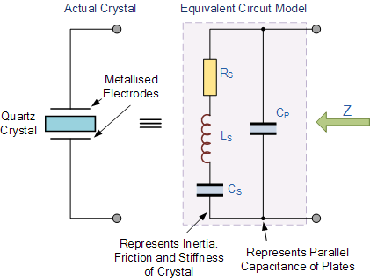

**Figure:** Equivalent Circuit Diagram of Quartz Crystal

The equivalent electrical circuit for the quartz crystal shows a series RLC circuit, which represents the mechanical vibrations of the crystal, in parallel with a capacitance, Cp which represents the electrical connections to the crystal. Quartz crystal oscillators tend to operate towards their “Series Resonance”.

The equivalent impedance of the crystal has a series resonance where Cs resonates with inductance, Ls at the crystals operating frequency. This frequency is called the crystals series frequency, ƒs. As well as this series frequency, there is a second frequency point established as a result of the parallel resonance created when Ls and Cs resonates with the parallel capacitor Cp as shown.

* **Crystal Impedance Against Frequency**

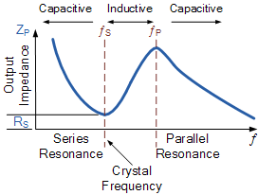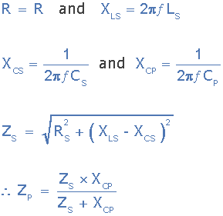

**Figure:** Crystal Impedance Against Frequency

The slope of the crystals impedance above shows that as the frequency increases across its terminals. At a particular frequency, the interaction of between the series capacitor Cs and the inductor Ls creates a series resonance circuit reducing the crystals impedance to a minimum and equal to Rs. This frequency point is called the crystals series resonant frequency ƒs and below ƒs the crystal is capacitive.

As the frequency increases above this series resonance point, the crystal behaves like an inductor until the frequency reaches its parallel resonant frequency ƒp. At this

frequency point the interaction between the series inductor, Ls and parallel capacitor, Cp creates a parallel tuned LC tank circuit and as such the impedance across the crystal reaches its maximum value.

Then we can see that a quartz crystal is a combination of a series and parallel tuned resonance circuits, oscillating at two different frequencies with the very small difference between the two depending upon the cut of the crystal. Also, since the crystal can operate at either its series or parallel resonance frequencies, a crystal oscillator circuit needs to be tuned to one or the other frequency as you cannot use both together.

So depending upon the circuit characteristics, a quartz crystal can act as either a capacitor, an inductor, a series resonance circuit or as a parallel resonance circuit and to demonstrate this more clearly, we can also plot the crystals reactance against frequency as shown.

* **Crystal Reactance against Frequency**

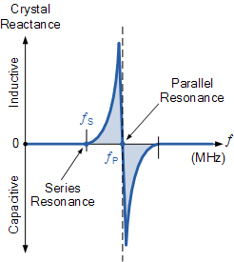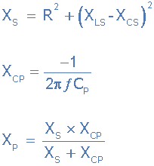

**Figure** :Crystal Reactance against Frequency

The slope of the reactance against frequency above, shows that the series reactance at frequency ƒs is inversely proportional to Cs because below ƒs and above ƒp the crystal appears capacitive. Between frequencies ƒs and ƒp, the crystal appears inductive as the two parallel capacitances cancel out.

* **Series Resonant Frequency :**

**osc62.gif**

* **Parallel Resonant Frequency :**

The parallel resonance frequency, ƒp occurs when the reactance of the series LC leg equals the reactance of the parallel capacitor, Cp

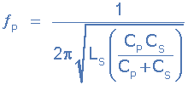

**7.3 CONCLUSION**

In crystal oscillators, the usual electrical resonant circuit is replaced by a mechanically vi­brating crystal. The crystal (usually quartz) has a high degree of stability in holding con­stant at whatever frequency the crystal is originally cut to operate. The crystal oscillators are, therefore, used whenever great stability is needed, for example, in communication trans­mitters, and receivers, digital clocks etc.

A quartz crystal exhibits a very important property known as piezo-electric effect. When a mechanical pressure is applied across the faces of the crystal, a voltage proportional to the applied mechanical pressure appears across the crystal. Conversely, when a voltage is applied across the crystal surfaces, the crystal is distorted by an amount proportional to the applied voltage. An alter­nating voltage applied to a crystal causes it to vibrate at its natural frequency.